IREVOLUTION: APPLE IPHONE MARKET ANALYTICS & WEB DEPLOYMENT
Team Details :
Team ID : LTVIP2026TMIDS84254
Team Size : 4
Team Leader : Vishnu Vardhan Goud
Team member : Bhavya Sri
Team member : B Charvi
Team member : Kaki Balu

TABLE OF CONTENTS
- INTRODUCTION
  - 1.1 Project Overview
  - 1.2 Purpose
- IDEATION PHASE
  - 2.1 Problem Statement
  - 2.2 Empathy Map Canvas
  - 2.3 Brainstorming
- REQUIREMENT ANALYSIS
  - 3.1 Customer Journey Map
  - 3.2 Solution Requirement
  - 3.3 Data Flow Diagram
  - 3.4 Technology Stack
- PROJECT DESIGN
  - 4.1 Problem Solution Fit
  - 4.2 Proposed Solution
  - 4.3 Solution Architecture
- PROJECT PLANNING & SCHEDULING
  - 5.1 Project Planning
- FUNCTIONAL AND PERFORMANCE TESTING
  - 6.1 Performance Testing
- RESULTS
  - 7.1 Output Screenshots
- ADVANTAGES & DISADVANTAGES
- CONCLUSION
- FUTURE SCOPE
- APPENDIX

1. INTRODUCTION
1.1 Project Overview The iRevolution project is an advanced data visualization and web integration study focused on Apple Inc.'s smartphone ecosystem. Utilizing a dataset encompassing 2006–2022, the project explores revenue trajectories, global market share, and technical specifications of various iPhone models. The project concludes with a fully responsive web application built using the Flask framework.
1.2 Purpose The objective is to bridge the gap between complex raw data and executive decision-making. By converting fragmented CSV files into a unified interactive platform, the project provides a granular view of Apple’s "Premiumization" strategy, specifically within the Indian market.
2. IDEATION PHASE
2.1 Problem Statement Corporate stakeholders currently struggle with "Data Silos"—where sales, technical specs, and regional data are stored separately. This fragmentation prevents marketing teams from understanding how hardware features (like battery capacity) correlate with regional sales volume in price-sensitive markets like India.
2.2 Empathy Map Canvas The project addresses the "Aspirational Tech Consumer":
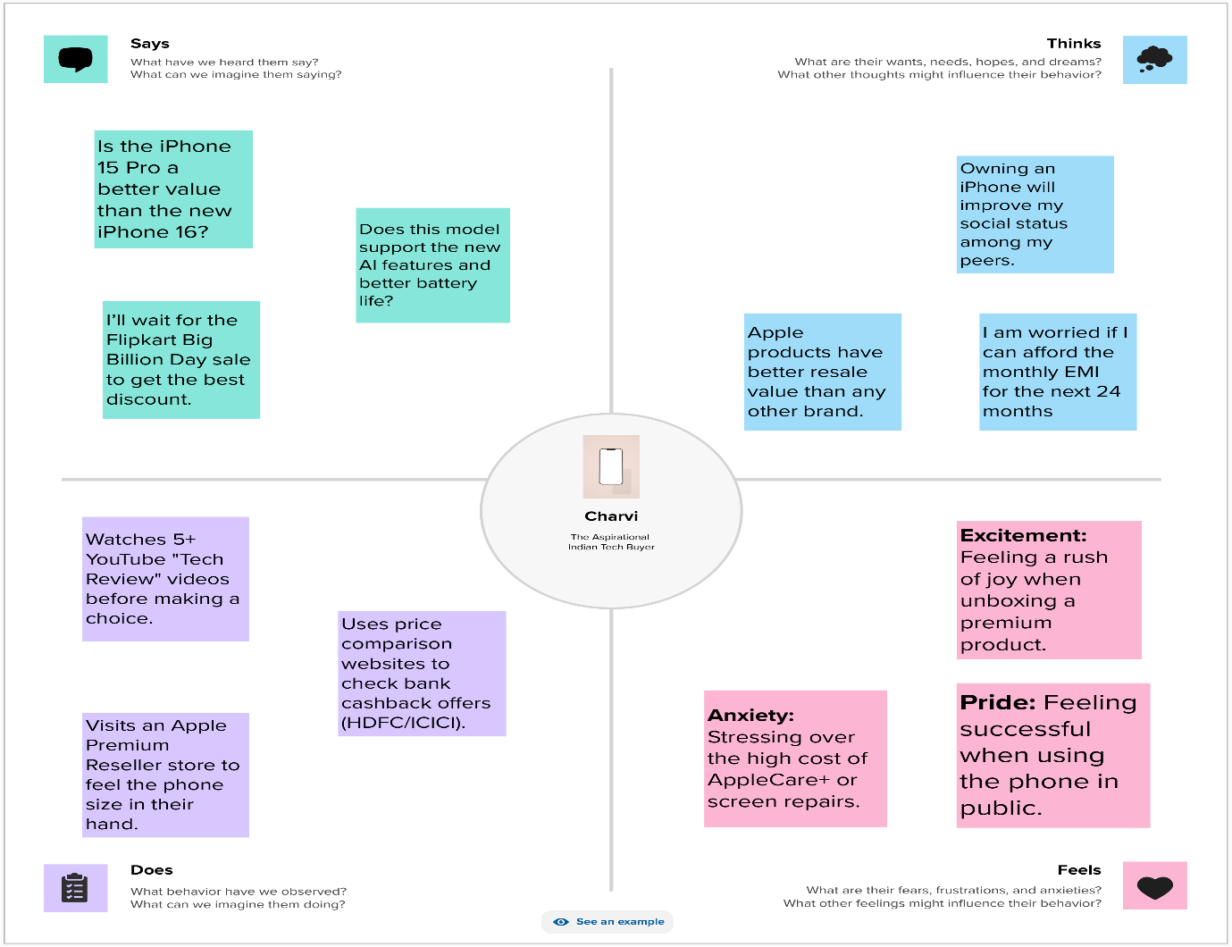
- Sensory: Sees high-gloss marketing but feels the weight of the high price point.
- Psychological: Views the iPhone as a status symbol and a long-term investment due to high resale value.
- Behavioral: Relies heavily on third-party retailers (Flipkart/Amazon) and aggressive 24-month EMI schemes.
2.3 Brainstorming Phase 1 focused on identifying the "Super-Premium" trend. Phase 2 involved designing a "12-Point Story" narrative to guide users through the data rather than just presenting static charts.
3. REQUIREMENT ANALYSIS
3.1 Customer Journey Map 1. Awareness: Social media and global launch events. 2. Discovery: Comparing model-wise specifications (e.g., iPhone 13 vs. 14). 3. Evaluation: Checking regional availability and financing offers. 4. Acquisition: Final purchase via integrated digital storefronts.
3.2 Solution Requirement The system must support:
- Dynamic Filtering: Ability to sort by Year, Model, and Battery Type.
- Geographical Mapping: A global interactive map for market penetration.
- Financial KPIs: Real-time summary of total revenue and average price points.
3.3 Data Flow Diagram Raw data is ingested from 7 CSV files, joined in Tableau via a "Model Name" primary key, and published to a cloud server where it is fetched by the Flask frontend.
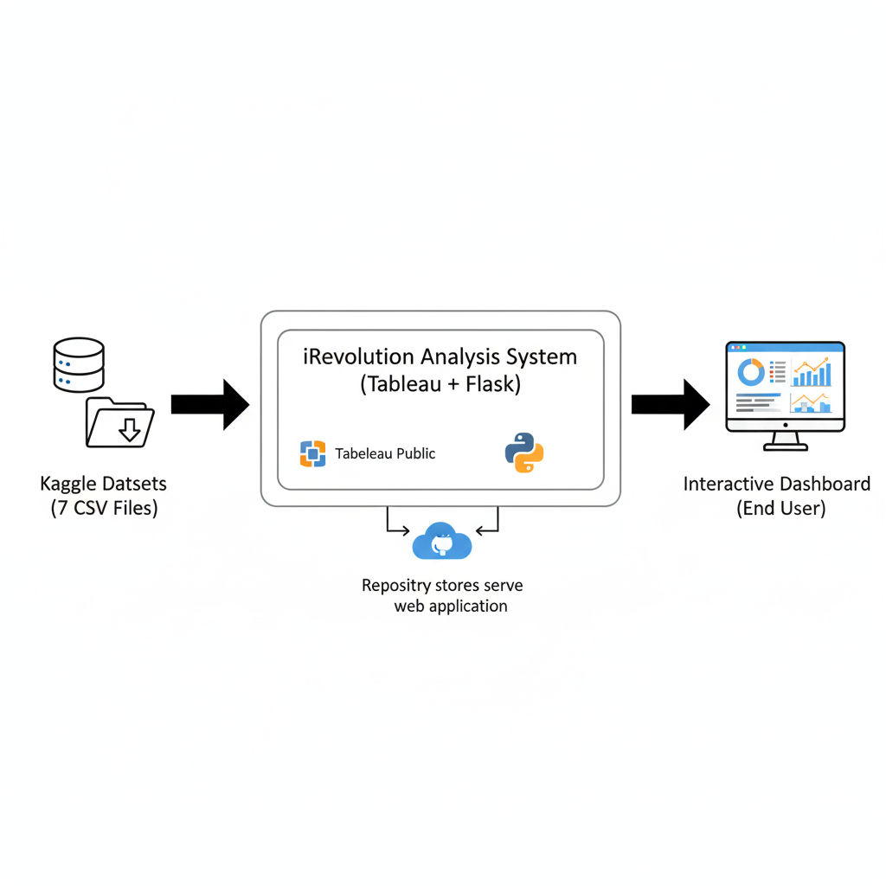
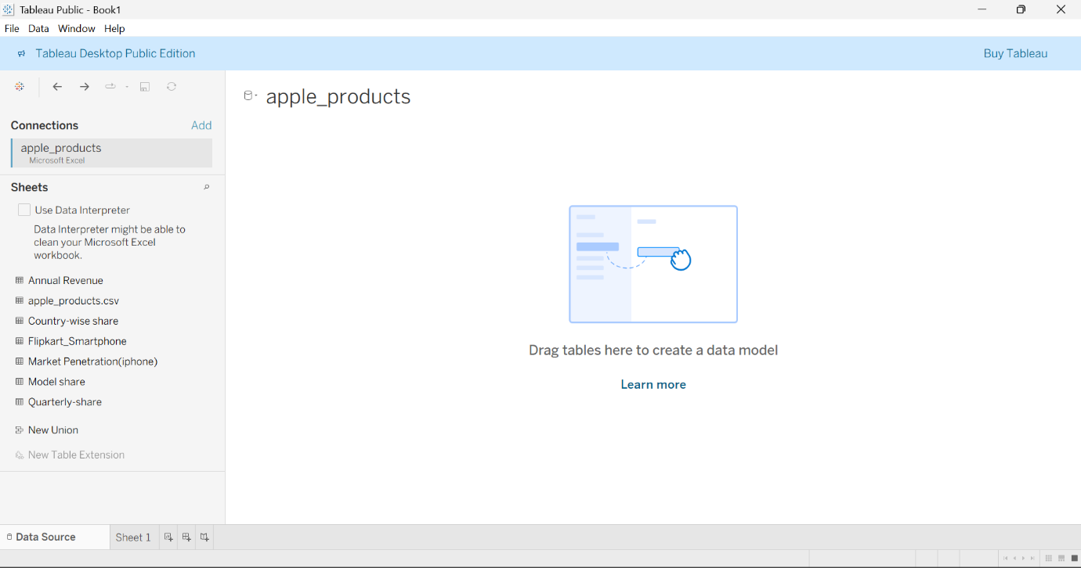3.4 Technology Stack
- Analytics: Tableau Public.
- Web: Python (Flask), HTML, CSS, JS.
- UI Framework: Bootstrap (Arsha Theme).
4. PROJECT DESIGN
4.1 Problem Solution Fit By consolidating 11 distinct visualizations (Bubble charts, Line trends, and Maps), the solution provides a 360-degree view of the business, solving the fragmented data problem.
4.2 Proposed Solution A professional-grade web portal featuring:
- Dashboard Page: High-level executive overview.
- Story Page: Detailed "deep-dive" into market milestones.
- Report Page: Project methodology and testing data.
4.3 Solution Architecture The architecture follows the Model-View-Controller (MVC) pattern where Flask handles the routing, and the View is rendered using embedded Tableau Javascript APIs.
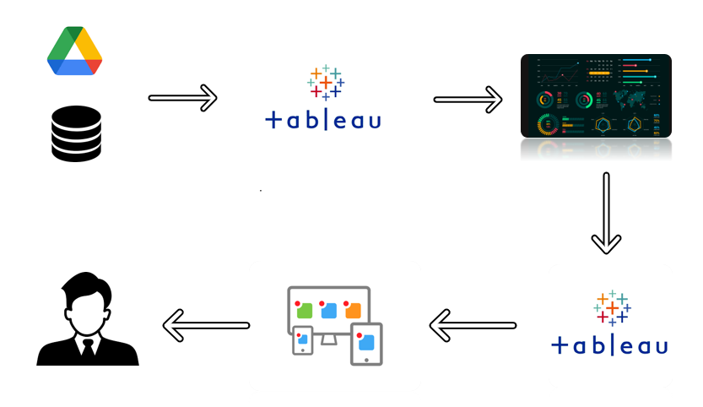
5. PROJECT PLANNING
The project followed a Sprint:
- 1: Data Extraction & Cleaning (Handling nulls in battery/price fields).
- 2: KPI Development & Dashboard UI Design.
- 3: Story Narration & Insight Annotation.
- 4: Flask Backend Coding & Template Integration.
6. TESTING
6.1 Performance Testing *
- Amount of Data Rendered
Across the 7 datasets, approximately 950+ rows and 35+ columns were imported into Tableau.
- Utilization of Filters
Filters used or applicable:
Model Filter
Country Filter
Year Filter
Battery Type Filter
- Number of Visualizations
Total: 11 Visualizations
- Number of Calculated Fields
Total: 2 Calculated Fields
Average Original Price(in battery type bar chart)
Sales Share %(in donut chart)
7. RESULTS
7.1 Output Screenshots
Dashboard in web ui
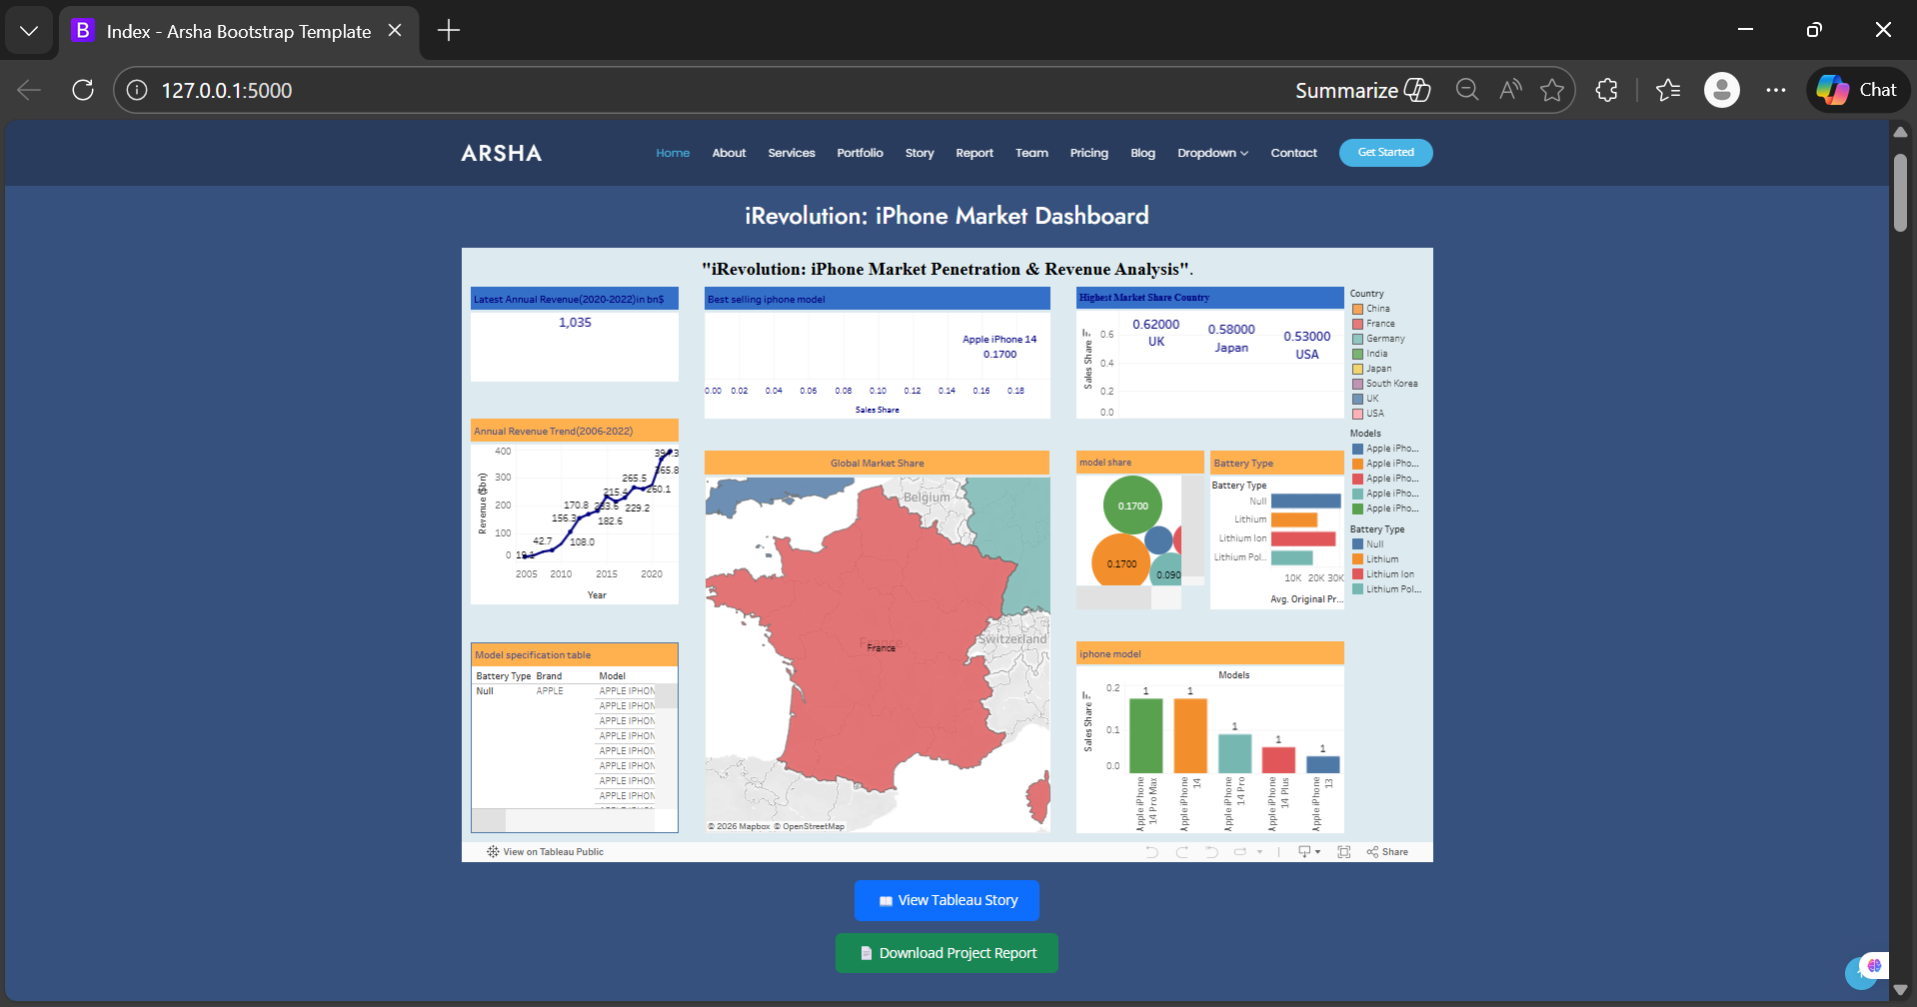
- published dashboard:
https://public.tableau.com/views/Book2_17711683798170/irevolutioniphonemarket
—> story in web ui
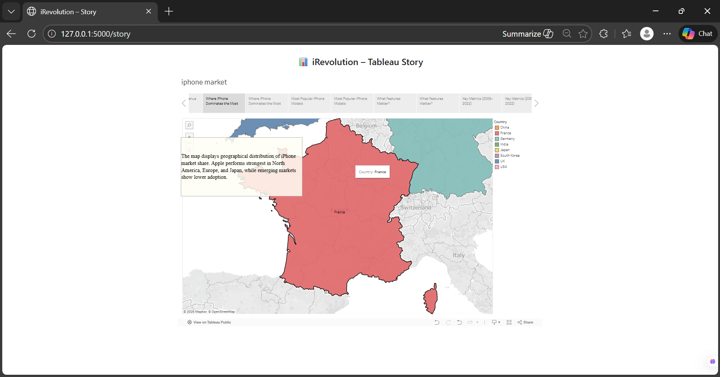
- published story:
https://public.tableau.com/shared/MY9JPTN77
—> Report in web Ui
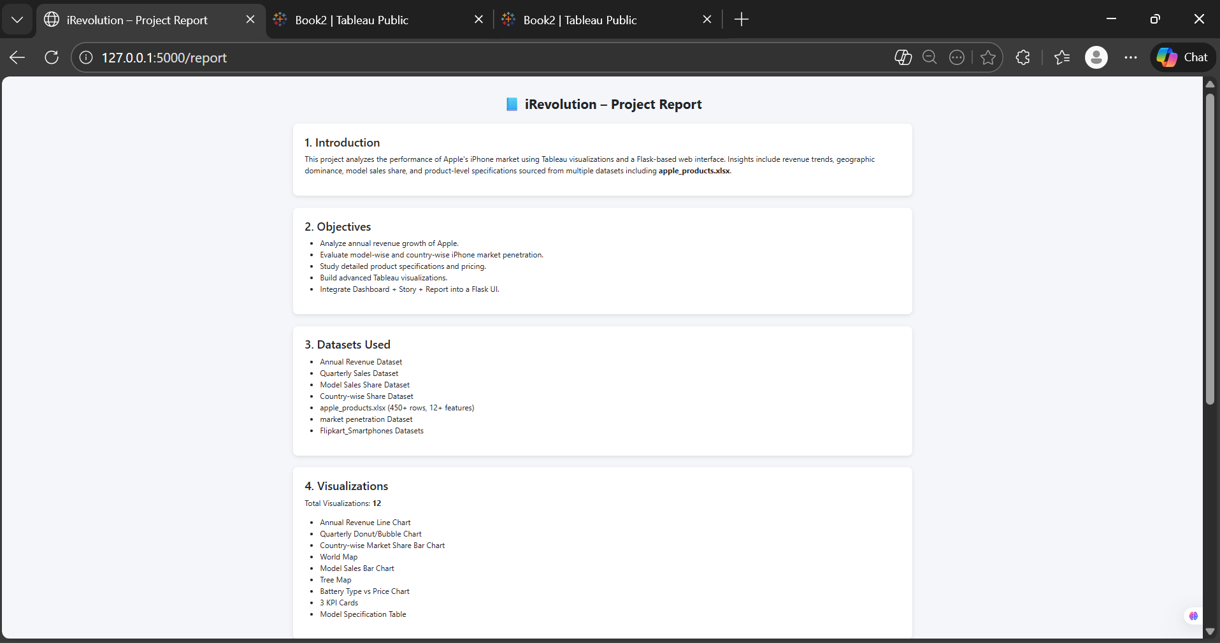
8. ADVANTAGES & DISADVANTAGES
- Advantages: Centralized insights; zero-installation web access; high visual engagement.
- Disadvantages: Significant internet bandwidth required for high-resolution iframe loading.
9. CONCLUSION
The iRevolution project successfully bridges the gap between raw data science and web engineering. It proves that interactive storytelling is the most effective way to communicate complex market trends to non-technical stakeholders.
10. FUTURE SCOPE
Expansion into Predictive Analytics using Python’s Scikit-learn to forecast future model sales and the integration of a Live API for real-time stock market correlation.
11. APPENDIX
Source Code: everything is provided in the the github link below :
https://github.com/charvi2911/iRevolution_-A-Data-driven-Exploration-of-Apple-s-iPhone-Impact-in-India
Dataset : https://docs.google.com/spreadsheets/d/1p1ZWaYcEuFl5UNFcmNvpkXi3JnoHamut/edit?usp=sharing&ouid=113247709954189786236&rtpof=true&sd=true
Empathy map :
https://app.mural.co/t/charvi9857/m/charvi9857/1771327792763/e4b6f6e1a402fde9c8f1d031b8e3f98f65da9ad6?sender=udddb569b65bfd8c7df175511
viedo demo :https://drive.google.com/file/d/1vQmE2yiQ62lw8IAVTkI4ae-SRFnSNZG-/view?usp=sharing

